# AEM TASK – 9

**Newsroom Portfolio**

## Header Configuration

* Used the **OOTB header component**.
* Created the following menu items in the header:
  + **Home**
  + **News**
  + **About Me**
  + **Contact Me**
* Styled the header appropriately to maintain a professional look.
* Implemented various news pages that displays the latest articles.

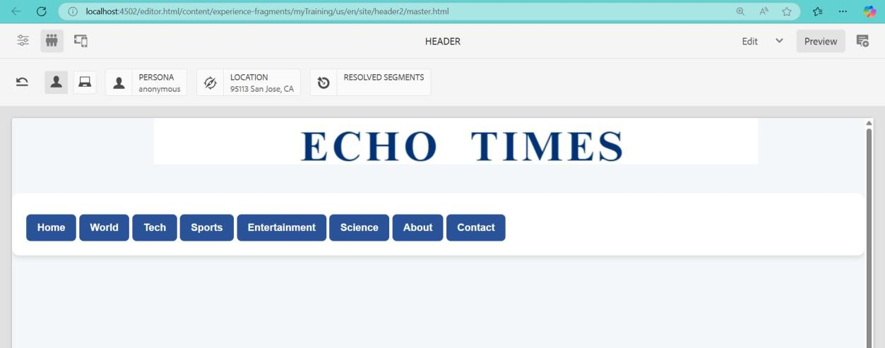

/apps/your-project/components/newsroom

├── newsroom.html

├── _cq_dialog/.content.xml

├── NewsroomModel.java

## Footer Configuration

* The footer includes:
  + **About Me Section**
  + **Contact Me Section**
  + **Social Media Links**
* Ensured footer consistency across all pages by including it at the template level.

Footer.html

<div class="footer">

<div class="footer-about">

<h3>About Me</h3>

<p>${properties.aboutMe}</p>

</div>

<div class="footer-contact">

<h3>Contact Me</h3>

<p>Email: ${properties.email}</p>

<p>Phone: ${properties.phone}</p>

</div>

<div class="footer-social">

<h3>Follow Me</h3>

<ul>

<li><a href="${properties.facebook}" target="_blank">Facebook</a></li>

<li><a href="${properties.twitter}" target="_blank">Twitter</a></li>

<li><a href="${properties.instagram}" target="_blank">Instagram</a></li>

</ul>

</div>

</div>

_cq_dialog/.content.xml code

<?xml version="1.0" encoding="UTF-8"?>

<jcr:root

xmlns:sling="http://sling.apache.org/jcr/sling/1.0"

xmlns:cq="http://www.day.com/jcr/cq/1.0"

xmlns:jcr="http://www.jcp.org/jcr/1.0"

jcr:primaryType="cq:Dialog"

title="Footer Configuration"

xtype="dialog">

<items jcr:primaryType="cq:TabPanel">

<items jcr:primaryType="cq:WidgetCollection">

<footerTab

jcr:primaryType="cq:Panel"

title="Footer Content">

<items jcr:primaryType="cq:WidgetCollection">

<aboutMe

jcr:primaryType="cq:Widget"

fieldLabel="About Me"

name="./aboutMe"

xtype="textarea"/>

<email

jcr:primaryType="cq:Widget"

fieldLabel="Email"

name="./email"

xtype="textfield"/>

<phone

jcr:primaryType="cq:Widget"

fieldLabel="Phone"

name="./phone"

xtype="textfield"/>

<facebook

jcr:primaryType="cq:Widget"

fieldLabel="Facebook URL"

name="./facebook"

xtype="textfield"/>

<twitter

jcr:primaryType="cq:Widget"

fieldLabel="Twitter URL"

name="./twitter"

xtype="textfield"/>

<instagram

jcr:primaryType="cq:Widget"

fieldLabel="Instagram URL"

name="./instagram"

xtype="textfield"/>

</items>

</footerTab>

</items>

</items>

</jcr:root>

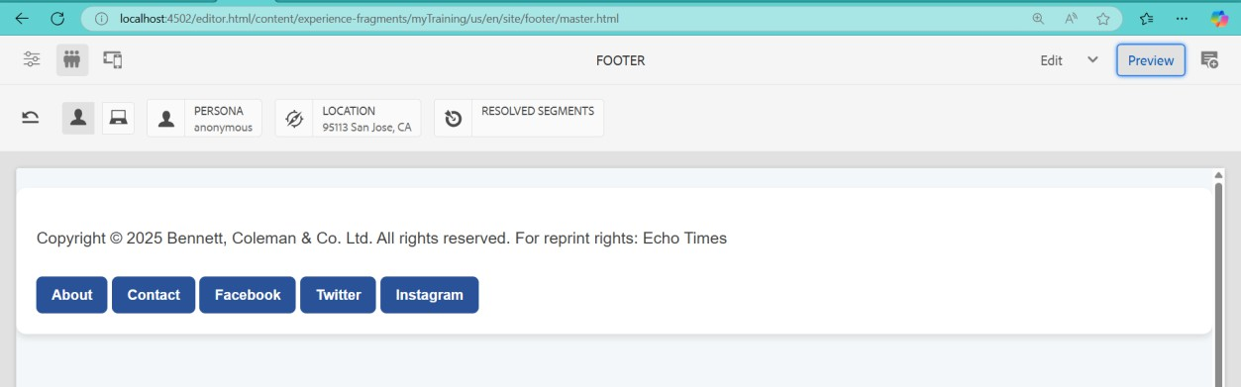

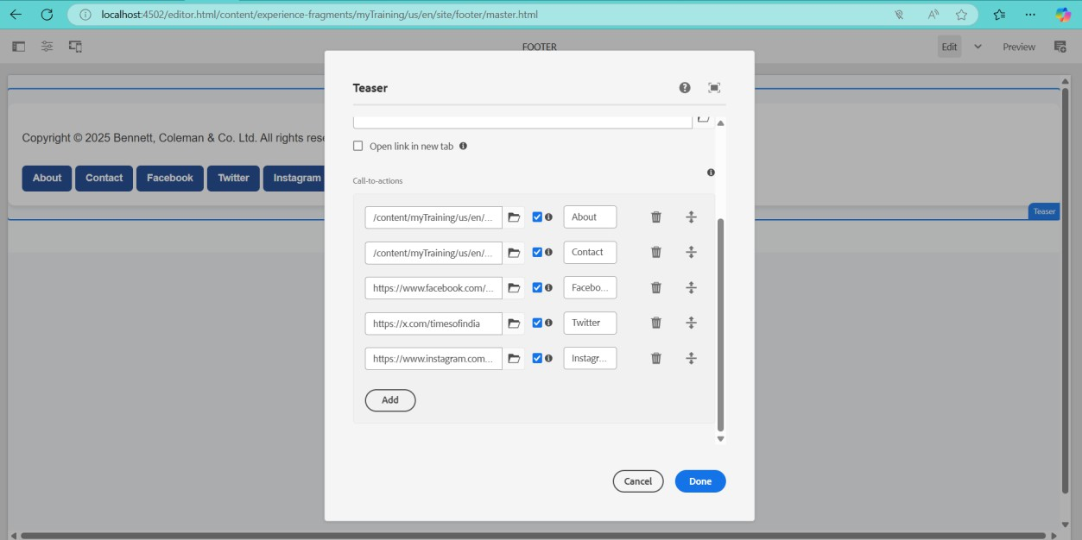

## Homepage Implementation

* Used the **OOTB Teaser Component**.
* Displayed an award ceremony section for journalists with:
  + **Image**
  + **Title**
  + **Description**
  + **CTA (Call to Action)** linking to a dedicated award page.

# Home Page



## Newsroom Component Development

* Created a **Newsroom Component** to fetch and display news dynamically.
* The component retrieves all news articles under /content/news.
* Each news article is displayed as a **card** containing:
  + **Title**
  + **Image**
  + **News Details**
  + **Unique Content for Each Card**



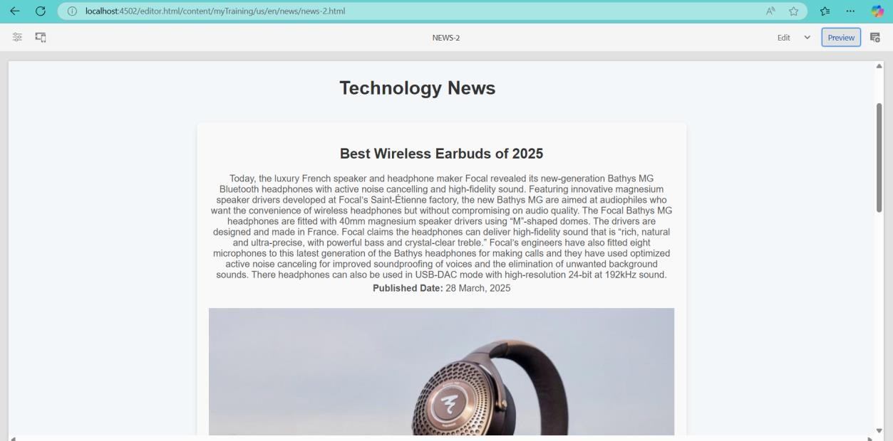

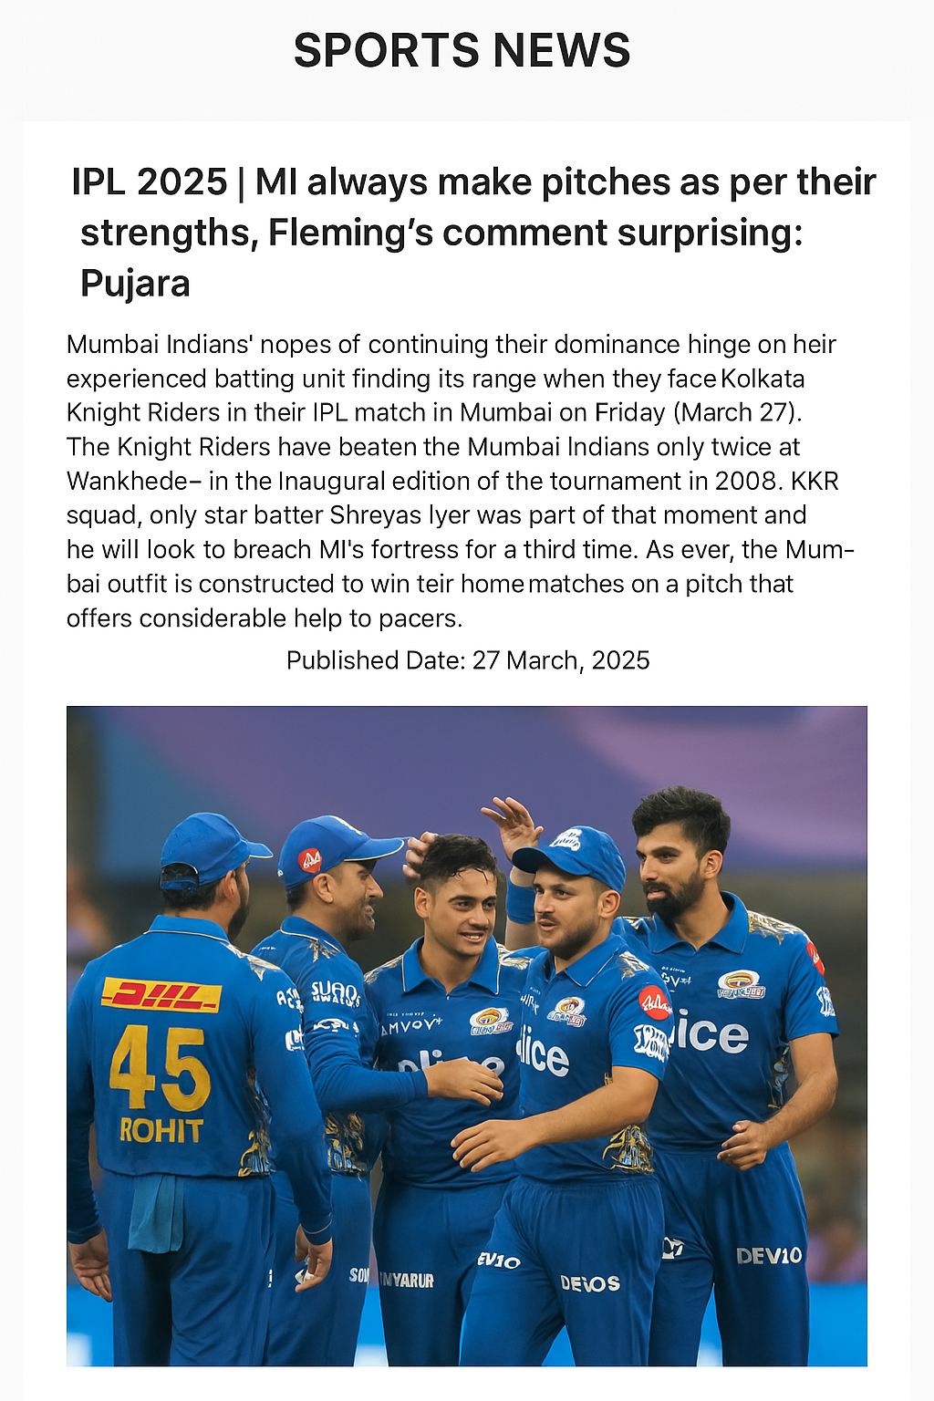

## News Article Pages

* Created news article pages under the /content/news hierarchy.
* Each page is authored with:
  + **Title**
  + **Image**
  + **Text Component** (for article content)
* Ensured the Newsroom component fetches data dynamically from these authored pages.

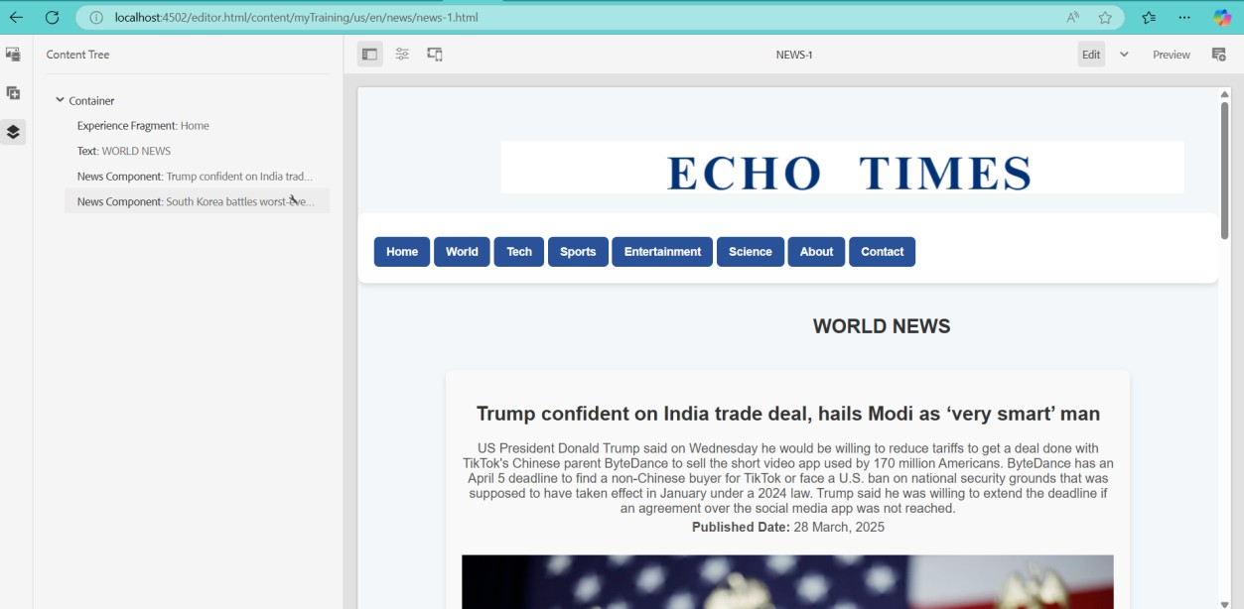

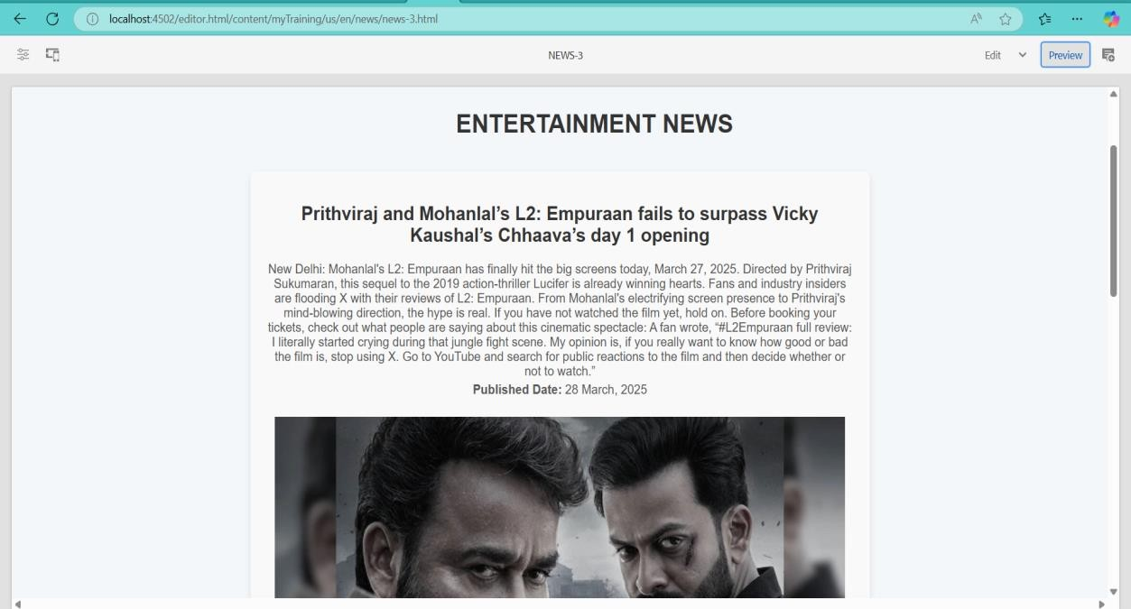

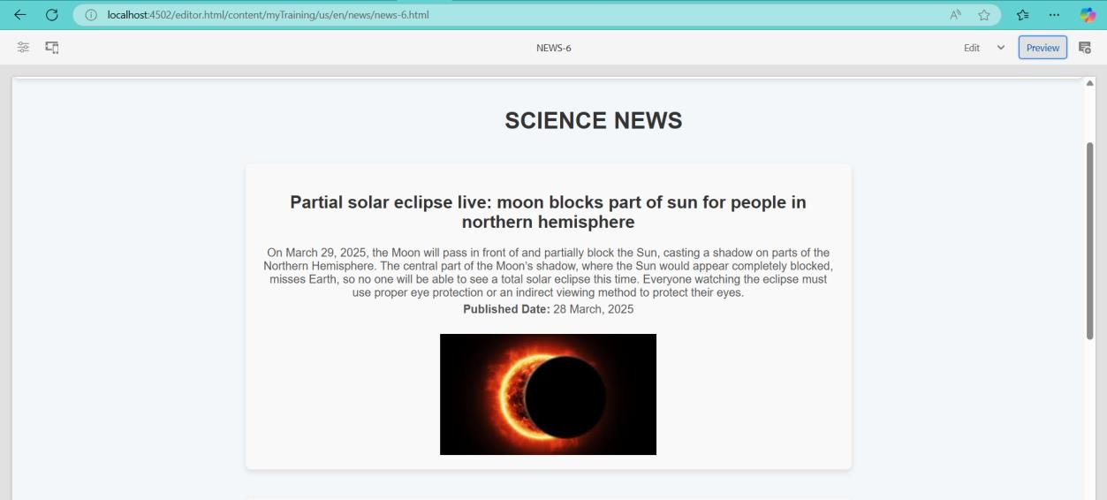

## About Me Page Implementation

* Used a **Journalist Component** to provide information about the journalist.

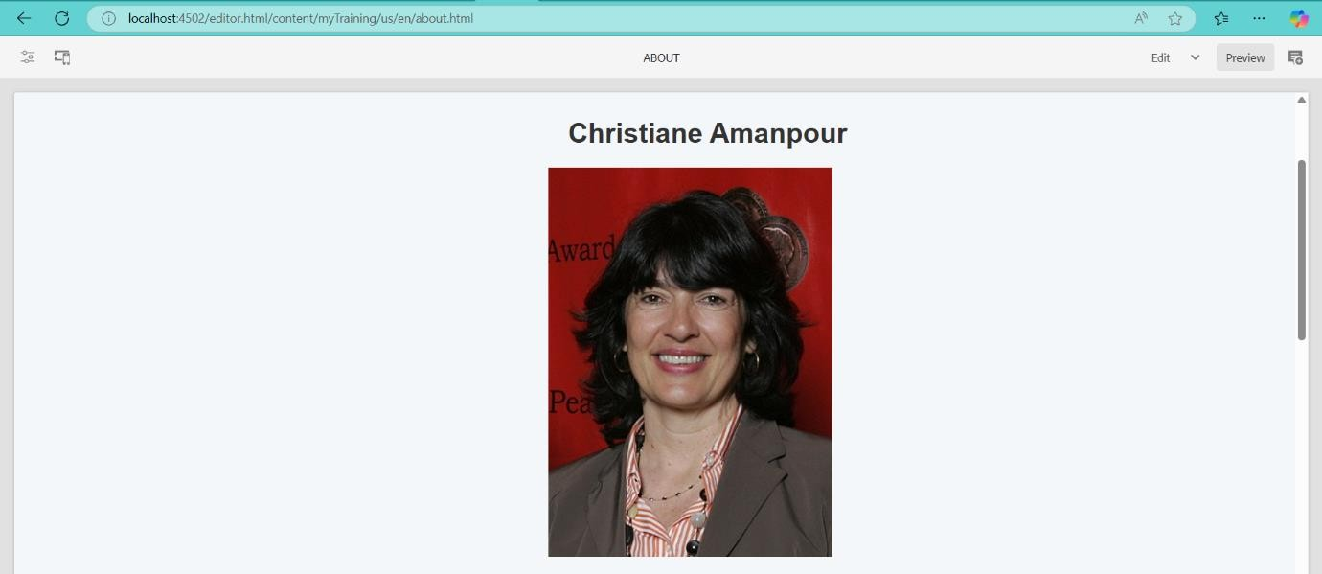

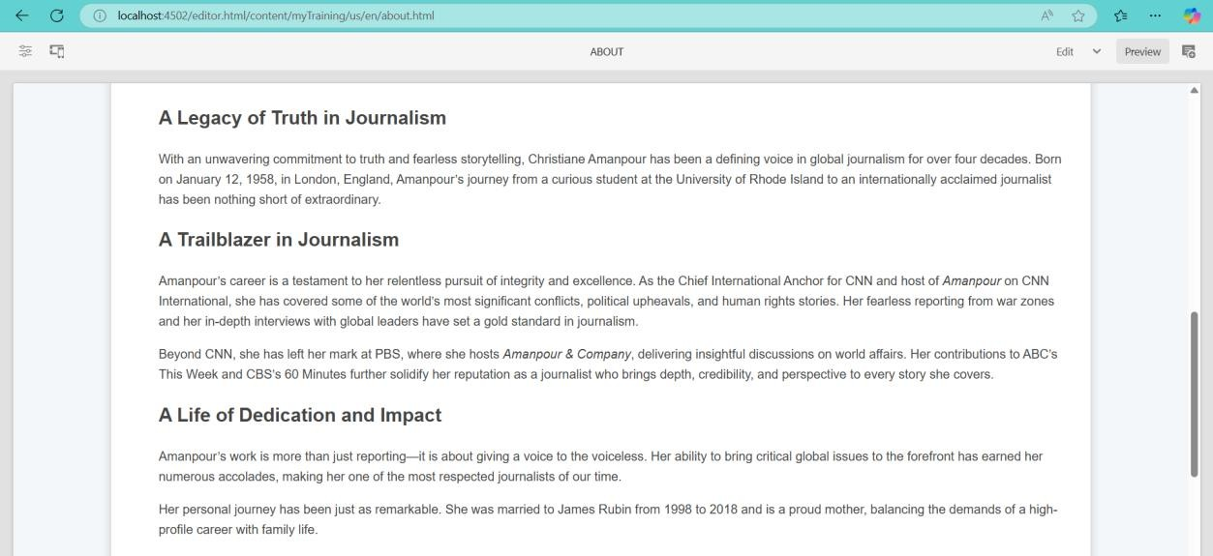

## Contact Me Page Implementation

* Used Teaser **Component** to:
  + Display contact details
  + Provide social media profile links for users to follow the journalist

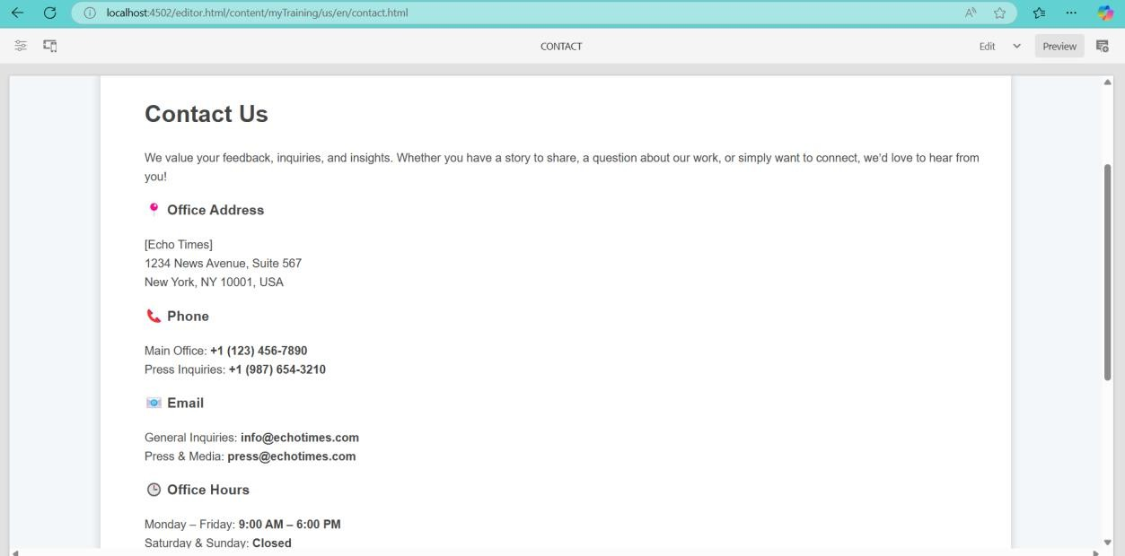

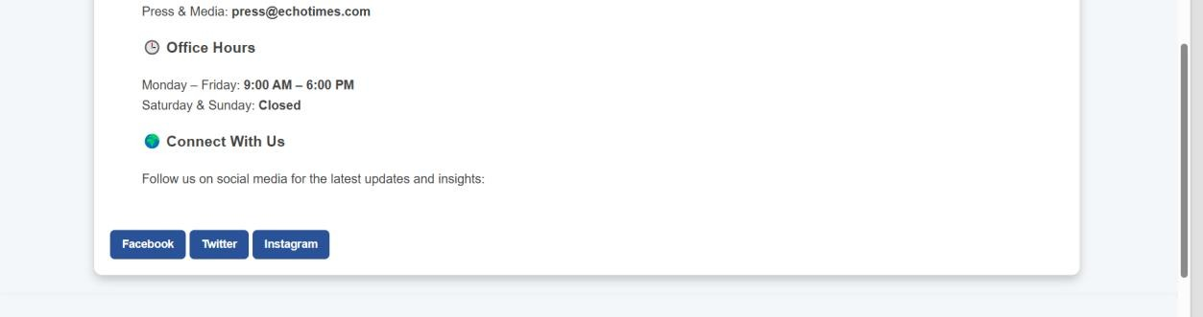

## Template-Level Implementation

* **Header and Footer** were added at the **template level** to ensure consistency across all pages.
* **Homepage** used the **OOTB Content Page Template**.
* **News Pages** used the **News Page Template** provided.

